Postman Tool authentication with Dynamics CRM 365 Online

Step 1:Download Postman Tool from this url https://www.postman.com/downloads/

Step 2:Get Login URL from your azure

[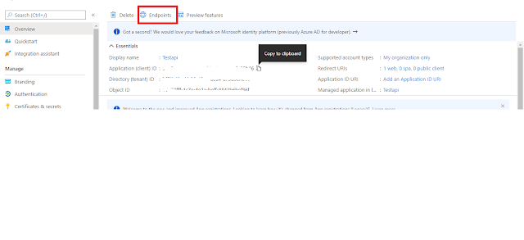](https://1.bp.blogspot.com/-xpsVYSqh_nE/X8NiYEQ7b6I/AAAAAAAAAGg/-y8d2O1uAmcz7MK4VitKkvPrdoQhhRINACLcBGAsYHQ/s1360/Capture17.PNG)

[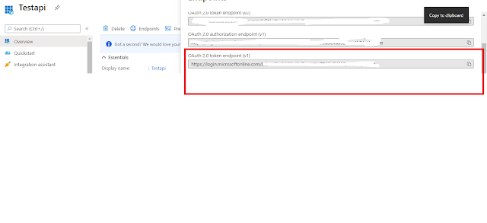](https://1.bp.blogspot.com/-N5KHwmqkAiw/X8NiYHznC9I/AAAAAAAAAGc/7cjIL9BMMWU5JFEHmwjb8mQ4o-hhLlWogCLcBGAsYHQ/s1360/Capture18.PNG)

Step3:Open Postman APP Enter Details as below

[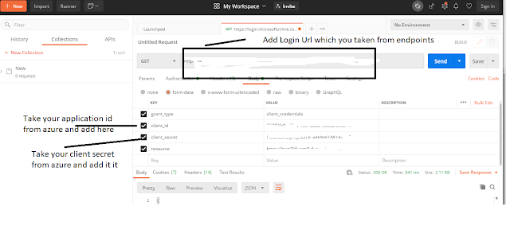](https://1.bp.blogspot.com/-auQ1yeFa-i0/X8NjfS0uaNI/AAAAAAAAAGw/veGfrU3jktQMz9ifZEbVS4Cvv9ISQjzMQCLcBGAsYHQ/s1360/Capture19.PNG)

Step 4:Client on Send it will give you token and copy access_token

[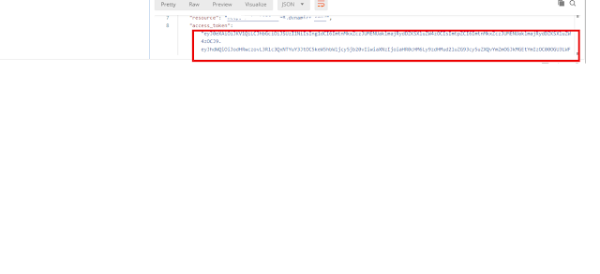](https://1.bp.blogspot.com/-sb85LEliI7I/X8NkB8_mE9I/AAAAAAAAAG4/5vPaPiwzSy4-xkuMbUR011mSZYz9bZaCwCLcBGAsYHQ/s1360/Capture20.PNG)

Step 5:Open New Tab in Postman and try to test if your api works well

[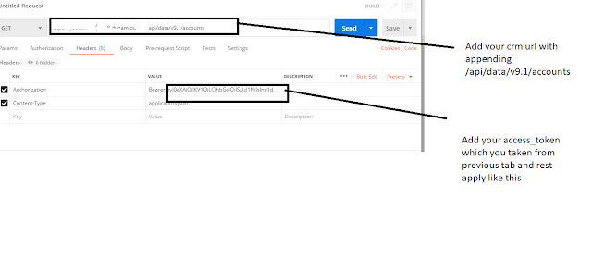](https://1.bp.blogspot.com/-iFiQX3SAg2Y/X8Nlr_lPdDI/AAAAAAAAAHE/F2Nag6rdag8hzbl5dysKZm5GRsttntBigCLcBGAsYHQ/s1360/Capture21.PNG)